Azure Private Link Workspace Setup Playbook

Created by:Filipe Ferrari Galan Deo//Last reviewed:Jun 1, 2026
Overview
Requirements for Workspace Creation
Baseline Architecture
Steps
Create a Metastore to enable Unity Catalog (Optional)
Create required network resources
Workspace VNET (Spoke)
Transit VNET (Hub)
Create the Azure Databricks workspaces
Create the Azure Databricks hybrid workspace (dev/stg/prd)
Create the Azure Databricks web authentication workspace
Create the Private Endpoints and DNS Zones
Backend (classic) Private Endpoint
Frontend (inbound) Private Endpoint
Browser authentication Private Endpoint
Configure internal DNS to redirect user requests to the web application (front-end)
Testing the setup
Disable Public Network Access for the workspace
Hub and Spoke
Steps
Peer Hub and Spoke VNETs
Create the Private Endpoints and DNS Zones
Backend (classic) + Frontend (inbound) Private Endpoint
Browser authentication Private Endpoint
Manage Private DNS zone links
Testing the setup

Overview
This playbook covers the setup of an Azure Databricks workspace with full private link support: Classic (Backend) and Inbound (Frontend). This is supposed to be an opinionated document. The exact setup details and considerations should be handled on a case-by-case basis, aligned with customers’ specific Azure resources and networking architecture.

Requirements for Workspace Creation
- Azure subscription with sufficient quota for the target region (vCPUs, Public IPs, NAT Gateways)
- Azure RBAC permissions
- For a list of Azure permissions, refer to Create a workspace: Required Azure permissions

Baseline Architecture
The first few sections of this guide outline a baseline for setting up a Full PL workspace. The following diagram illustrates a baseline architecture:
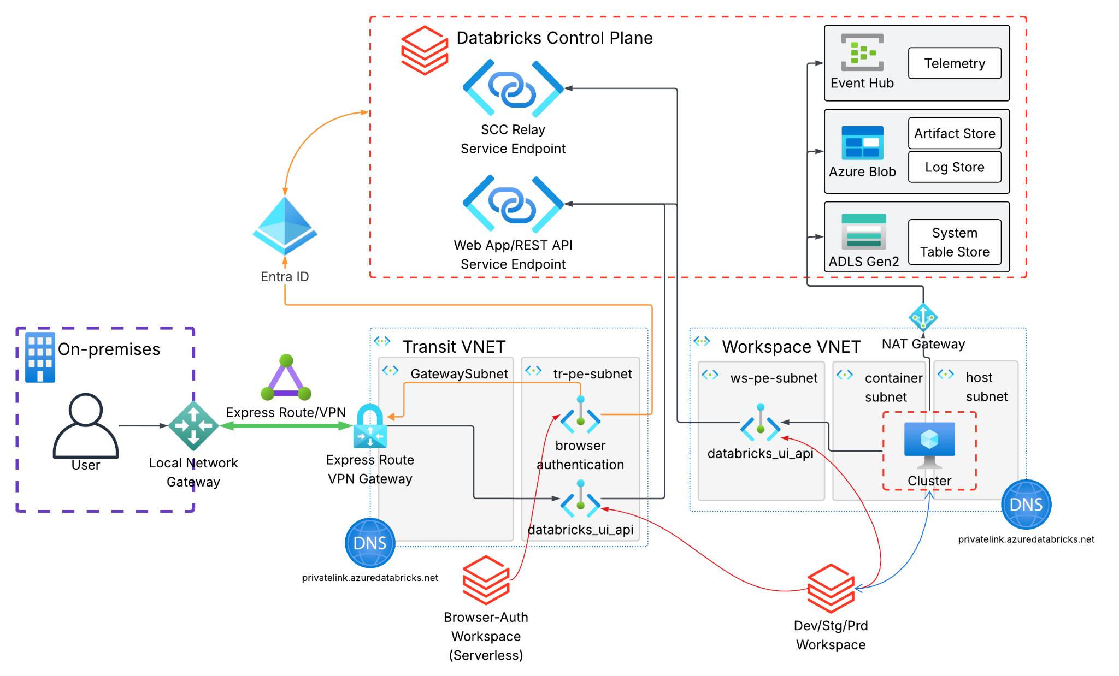

Steps

Create a Metastore to enable Unity Catalog (Optional)
The Metastore is the top-level component in the Unity Catalog hierarchy. It is shared across all workspaces in the same Databricks Account and region. The principal who creates a metastore will become its default Metastore Admin. The Metastore Admin is a highly privileged role, which can grant itself permissions over all securable objects (associated with that specific metastore) in the Unity Catalog hierarchy (Catalogs, Schemas, Tables, Models, etc.). The following actions must be performed from the Azure Databricks Account Console.
Whenever you create an Azure Databricks workspace for the first time, your Azure Databricks account will be created. The user that created the workspace will not necessarily be an account administrator. To find out who is the first Azure Databricks Account administrator, navigate to Entra ID in the Azure portal, find Roles and administrators, and search for the Global Administrator. Ask any of the Global Administrators to access Azure Databricks Account Console.
You can also check whether you have Account Admin access by authenticating on the link above. If you see the list of workspaces you have access to, you do not have Account Admin privileges. If you see the Account Console dashboard, you have access. You can skip this section if you already have a metastore created in this account and region, or if this is your first Databricks workspace (the account console is only available after the first workspace is created).
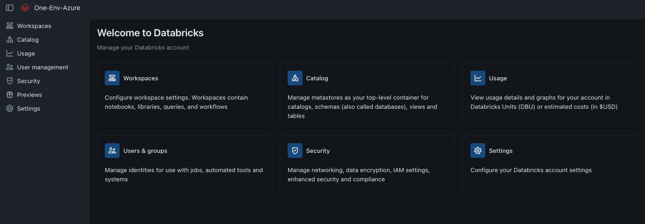
- Select the Catalog option in the sidebar:
  - Select the option to Create metastore
  - Add a descriptive name and select the region where you plan to deploy all your resources.
  - It is recommended that you leave the ADLS Gen 2 path and Access Connector Id (optional) inputs empty. We recommend enforcing separation for your storage at the catalog level, as will be shown later in this document.
  - Create the metastore
  - (Optional) Enable “Automatically assign new workspaces in <region> to this metastore”
  - Skip the Workspace assignment.

Create required network resources
The architecture uses two VNets:
Workspace VNet (Spoke): Hosts the Databricks data plane subnets, the Backend Private Endpoint, and the NAT Gateway used for outbound traffic to the internet and to Azure services.
Transit VNet (Hub): Hosts the Frontend Private Endpoint and the browser_authentication Private Endpoint, enabling users to access the Databricks workspace without traversing the public internet. On-premises users reach this VNet via ExpressRoute or Site-to-Site VPN.
Note: This guide does not cover the steps to create the Transit/Hub VNet, the ExpressRoute circuit, or VPN gateway. The Hub VNet and on-prem connectivity are assumed to already exist.
For details on Azure Databricks architecture, refer to this documentation.
For details on Private Link with Azure Databricks, refer to Azure Private Link concepts.

Workspace VNET (Spoke)
The following requirements for the Workspace VNet must be met:
- 1 VNet with an IPv4 address space of at least /24 (larger is recommended for future scaling)
- 2 dedicated subnets for the Databricks data plane, both delegated to Microsoft.Databricks/workspaces (minimum /26 each, larger is recommended):
  - host-subnet (also named “public subnet” — referred to as host-subnet hereafter)
  - container-subnet (also named “private subnet” — referred to as container-subnet hereafter)
  - Note: Delegation is done automatically during workspace creation. It is not required to delegate the subnets for manual deployments.
- 1 subnet for Private Endpoints (minimum /27 — referred to as pe-subnet hereafter)
- 1 NAT Gateway with at least one Public IP, attached to both host-subnet and container-subnet
- 1 Private Endpoint for the Backend Private Link connection (sub-resource databricks_ui_api)
- 1 Private DNS Zone privatelink.azuredatabricks.net linked to the Workspace VNet
Follow the steps below to create the Workspace VNet and its network resources:
- In the Azure portal, select Create a resource:
  - Search for “Virtual Network” in the Marketplace.
  - Select the resource named "Virtual network”, then click Create.
- In the Create virtual network Basics section:
  - Select the correct Subscription and Resource Group. If you don't yet have a Resource Group, click Create new and provide a Name.
  - Provide a Virtual network name and select the Region where you want the resources to be deployed.
  - Click Next.
- Keep all settings as defaults in the Security section. Click Next.
- You should be in the Address Space section, which will look like this:
  - Define the address space of your virtual network with with one or more IPv4 CIDR ranges. The default value is 10.0.0.0/16. Make sure the address space has a netmask of at least /24.
  - Configure the host-subnet, container-subnet and pe-subnet (you can edit the existing default subnet, or delete it and create new subnets)
  - After clicking Add a subnet or Edit subnet:
    - Provide a subnet Name, i.e., host-subnet, container-subnet, or pe-subnet.
    - Select the correct IPV4 address range, Starting address and Size. Make sure to choose a net mask of at least /26 for the host and container subnets, and /27 for the private endpoint subnet.
    - Make sure Enable private subnet (no default outbound access) is enabled for all three subnets. Azure no longer recommends default outbound access, given that explicit connectivity is preferred over implicit access. For more details, check Default outbound access in Azure.
    - Click Save.
    - Repeat the process until all three subnets are defined. The Network should look like the below screenshot:
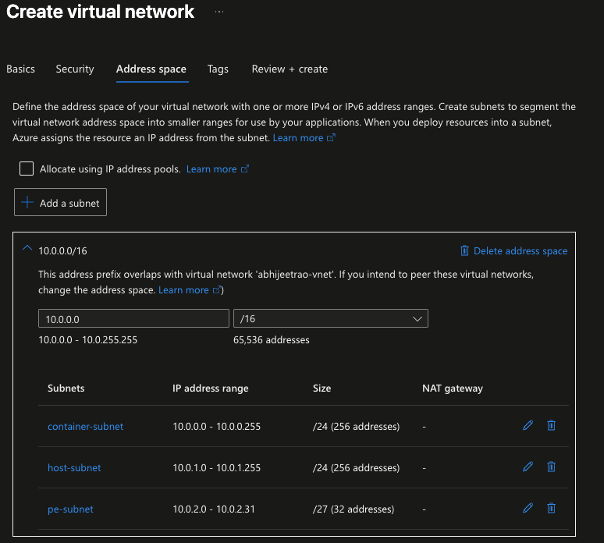
  - Click Next
- Provide any required tags in the Tags section. Click Review + create.
- Once the validation succeeds, click Create. The VNET should be ready in a few seconds.

Transit VNET (Hub)
Make sure the following requirements are met in your Transit VNET:
- Transit VNet is available
- 1 private subnet within Transit VNet is available for Frontend Private Endpoints (at least 2 private IP addresses - referred to as transit-pe-subnet hereafter)
- On-prem connection to the Hub VNet is established via ExpressRoute or Site-to-Site VPN (if on-prem users are expected to access the Databricks workspace via the Hub VNet)

Create the Azure Databricks workspaces
For this setup, we are following the best practice of having a dedicated workspace to host the browser_authentication. This helps avoid user access disruptions in case a workspace is deleted or recreated for any reason. For more details, check Configure Inbound Private Link - Step 3: Create a browser_authentication workspace.

Create the Azure Databricks hybrid workspace (dev/stg/prd)
In the Azure Portal or from the resource group blade, click Create or Create a resource
- Search for Azure Databricks, and click Create.
- In the Create an Azure Databricks workspace Basics section:
  - Select the correct Subscription and Resource Group. The resource group does not necessarily must be the same as the VNET resource group.
  - Enter the Workspace name.
  - Choose the same Region as the virtual network
  - For the Pricing tier, select Premium.
  - For Workspace type, choose hybrid.
  - (Optional) Provide a Managed Resource Group name. Every hybrid Databricks workspace has a managed resource group, where Databricks deploys and manages the lifecycle of a set of resources (storage account, access connectors, NSGs, VMs, etc.). If a name is not specified, a default name will be assigned.
  - Click Next: Networking.
- In the Networking section:
  - Select Yes for Deploy Azure Databricks workspace with Secure Cluster Connectivity (No Public IP) and Deploy Azure Databricks workspace in your own Virtual Network (VNet)
  - In the Virtual Network drop-down, select your Workspace (Spoke) Vnet
  - Fill in the subnet details for the public (host) and private (container) subnets. Make sure to copy the right subnet names from your Workspace Vnet.
  - Select Yes for the Deploy Azure Databricks workspace with NAT Gateway option.
  - Provide a NAT Gateway Name and NAT Gateway Public IP Name.
  - Keep Allow Public Network Access enabled for now, until the inbound (front-end) private link is fully implemented.
  - For Required NSG Rules, select No Azure Databricks Rules.
  - Check the screenshot below:
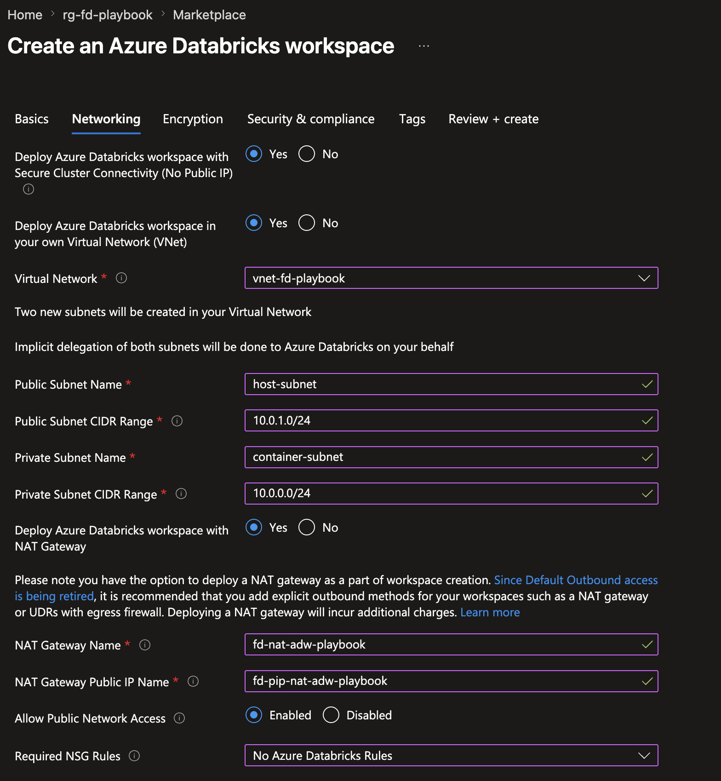
Note: For this guide, the private endpoints creation will be covered in the Create the Private Endpoints and DNS Zones section. You can leave Private endpoints in the Networking tab empty.
  - Click Review + Create
- Once the validation succeeds, click Create. The Workspace should be ready in a few minutes.

Create the Azure Databricks web authentication workspace
In the Azure Portal or from the resource group blade, click Create or Create a resource
- Search for Azure Databricks, and click Create.
  - Select the correct Azure Subscription and Resource Group.
  - Under Instance Details, provide a Workspace name. As a suggestion, include the purpose (webauth) and the workspace region. For example: adw-webauth-<region>.
  - Select the Region where the workspace will be created, and ensure Premium is selected for the Pricing Tier.
  - For Workspace Type, select Serverless.
  - Click Next: Networking
- In the Networking tab:
  - Select Disabled for Allow Public Network Access.
  - Click Review + create.
- Once the validation succeeds, click Create. The Workspace should be ready in a few minutes.
Note: The web authentication workspace does not necessarily need to be serverless. In this guide, we're using a serverless workspace for simplicity and to avoid creating dedicated subnets. This workspace only exists to host the browser_authentication private endpoint, and no user access or compute resources are expected. We are intentionally disabling public access to the workspace while the front-end (inbound) private link is not configured, keeping the workspace inaccessible.

Create the Private Endpoints and DNS Zones
After creating both workspaces, we can proceed with creating the required private endpoints. For this setup, we'll create the three private endpoints, as described below:
Private Endpoint | Sub-resource | VNet / Subnet | Purpose
Backend (classic) PE | databricks_ui_api | Workspace VNet / pe-subnet | Clusters → Databricks control plane (REST API, SCC Relay)
Frontend (inbound) PE | databricks_ui_api | Transit VNet (Hub) / hub-pe-subnet | End-user → workspace (Web App/REST API)
Browser auth PE | browser_authentication | Transit VNet (Hub) / hub-pe-subnet | Azure Entra ID SSO callback
Given the proposed network architecture, we will consider two distinct private DNS zones: one linked to the Transit VNET and the other linked to the Workspace VNET. This is required for this baseline architecture because it uses separate endpoints for backend and frontend access (it is not possible to create two A records for the same endpoint in the same DNS Zone).

Backend (classic) Private Endpoint
To create the backend private endpoint:
- In the Azure portal, navigate to the Hybrid workspace we configured in Create the Azure Databricks hybrid workspace (dev/stg/prd):
  - In the Azure resource blade, expand the Settings section on the left side of the screen, and click Networking.
  - Click Private Endpoint Connections and then + Private Endpoint.
- In the Create a private endpoint page:
  - Select the correct Subscription and the Resource Group where the Workspace VNET is created.
  - Provide a Name for the private endpoint. It is recommended to add a reference to the workspace, the sub-resource, and to note that this is a backend private endpoint. For example: pe-<dev/stg/prod>-uiapi-backend. The Network Interface Name should be filled automatically.
  - Select the Region. Make sure it matches the same region where you deployed your hybrid workspace.
  - Click Next: Resource.
- In the Resource tab, in the Target sub-resource dropdown, choose databricks_ui_api. Click Next: Virtual Network.
- In the Virtual Network tab, select the Workspace VNET in the Virtual Network dropdown, and the pe-subnet in the Subnet dropdown. Click Next: DNS.
- In the DNS tab, select Yes for the Integrate with private DNS zone option. For the configuration, select the correct Subscription, and for the Resource Group, choose the same Resource Group where your Workspace VNET is located.
- Click Next: Tags and then Next: Review + create.
- Once the validation succeeds, click Create. The backend private endpoint should be ready in a few minutes.

Frontend (inbound) Private Endpoint
The frontend (inbound) private endpoint uses the same target sub-resource as the backend (classic) private endpoint. The difference is that this endpoint is hosted in the Transit VNET.
- In the Azure portal, navigate to the Hybrid workspace we configured in Create the Azure Databricks hybrid workspace (dev/stg/prd):
  - In the Azure resource blade, expand the Settings section on the left side of the screen, and click Networking.
  - Click Private Endpoint Connections and then + Private Endpoint.
- In the Create a private endpoint page:
  - Select the correct Subscription and the Resource Group where the Transit VNET is created.
  - Provide a Name for the private endpoint. It is recommended to add a reference to the workspace and to note that this is a frontend private endpoint. For example: pe-<dev/stg/prod>-uiapi-frontend. The Network Interface Name should be filled automatically.
  - Select the Region. Make sure it matches the same region where you deployed your hybrid workspace.
  - Click Next: Resource.
- In the Resource tab, in the Target sub-resource dropdown, choose databricks_ui_api. Click Next: Virtual Network.
- In the Virtual Network tab, select the Transit VNET in the Virtual Network dropdown, and the transit-pe-subnet in the Subnet dropdown. Click Next: DNS.
- In the DNS tab, select Yes for the Integrate with private DNS zone option. For the configuration, select the correct Subscription, and for the Resource Group, choose the same Resource Group where your Transit VNET is located.
- Click Next: Tags and then Next: Review + create.
- Once the validation succeeds, click Create. The backend private endpoint should be ready in a few minutes.

Browser authentication Private Endpoint
The browser_authentication endpoint is required to make Single Sign-On (SSO) work for web browser logins over a private connection. It securely handles the SSO authentication callbacks from Microsoft Entra ID that otherwise are blocked on a private network.
It is a best practice to have a dedicated workspace to host the browser_authentication private endpoint to prevent a single point of failure if other workspaces are deleted.
- In the Azure portal, navigate to the Serverless workspace we configured in Create the Azure Databricks web authentication workspace:
  - In the Azure resource blade, expand the Settings section on the left side of the screen, and click Networking.
  - Click Private Endpoint Connections and then + Private Endpoint.
- In the Create a private endpoint page:
  - Select the correct Subscription and the Resource Group where the Transit VNET was created.
  - Provide a Name for the private endpoint. It is recommended to note this is a browser_authentication endpoint, as well as the region where this is created. For example: pe-browser-auth-<region>. The Network Interface Name should be filled automatically.
  - Select the Region. Make sure it matches the same region where you deployed your workspaces.
  - Click Next: Resource.
- In the Resource tab, in the Target sub-resource dropdown, choose browser_authentication. Click Next: Virtual Network.
- In the Virtual Network tab, select the Transit VNET in the Virtual Network dropdown, and the transit-pe-subnet in the Subnet dropdown. Click Next: DNS.
- In the DNS tab, select Yes for the Integrate with private DNS zone option. For the configuration, select the correct Subscription, and for the Resource Group, choose the same Resource Group where your Transit VNET is located.
- Click Next: Tags and then Next: Review + create.
- Once the validation succeeds, click Create. The browser authentication private endpoint should be ready in a few minutes.

Configure internal DNS to redirect user requests to the web application (front-end)
You must ensure that when users attempt to access the workspace, the workspace URL resolves to the previously configured Private Endpoint IP addresses. The recommended approach consists of configuring conditional forwarding from on-premises DNS servers to forward queries for all Databricks domains to Azure's internal DNS.
Set up conditional forwarding for the following domains to your Azure DNS forwarder or Azure DNS Private Resolver:
- *.azuredatabricks.net
- *.privatelink.azuredatabricks.net
- *.databricksapps.com
For more details, check Custom DNS configuration.

Testing the setup
To test the backend (classic) private link is working as expected:
- Access the hybrid workspace you configured in Create the Azure Databricks hybrid workspace (dev/stg/prd).
- Create a classic compute cluster, and make sure it starts successfully.
- Create a notebook, attach it to the newly created classic cluster, and execute the following command:
%sh nslookup adb-<workspace_id>.azuredatabricks.net
- The nslookup command should resolve to the IP address of the private endpoint you configured in Backend (classic) Private Endpoint.
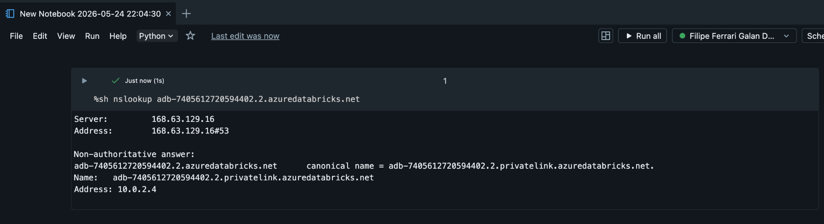
For the frontend private link, it is important to validate DNS resolution for both the workspace and browser authentication endpoints. Use your local terminal to validate the following commands:
nslookup adb-<workspace_id>.azuredatabricks.net
nslookup <region>.pl-auth.azuredatabricks.net
Considering your DNS server is properly configured with conditional forwarding, you should have the following result:
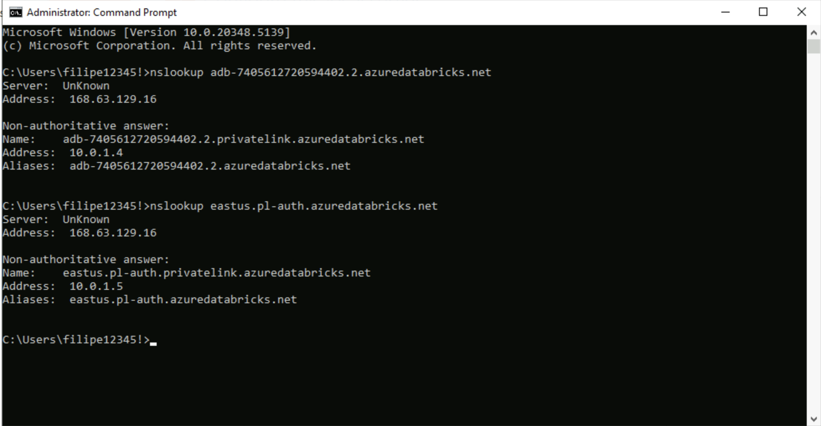

Disable Public Network Access for the workspace
After you've configured both private endpoints and DNS appropriately, you can disable Public Network Access to the workspace, ensuring that all access must be routed through Private Endpoints.
- From the workspace Overview, in the left pane under Settings, click Networking.
- For Allow Public Network Access, select Disabled.
- Click Save.
Once public access is disabled, make sure the workspace is accessible from your local machines through VPN. It is expected that only users connected to the network through VPN/Express Route will be able to access the workspace.

Hub and Spoke
The baseline architecture suggests completely separated endpoints for classic (backend) and inbound (frontend) access. Given that both endpoints target the same sub-resource type (databricks_ui_api), it is quite common to build an architecture where both backend and frontend access rely on the same databricks_ui_api endpoint. This type of architecture is often referred to as a hub and spoke architecture.
In this scenario, the Workspace VNET works as a spoke, and all the private endpoints are located in a Hub VNET. For this scenario, it is required to configure additional connectivity between the VNETs, to ensure the compute clusters can access the endpoints that are located in the Hub VNET. The most common connectivity method consists of configuring VNET peering between these VNETs, but a VNET-to-VNET VPN connection also works.
The below diagram illustrates this proposed architecture:
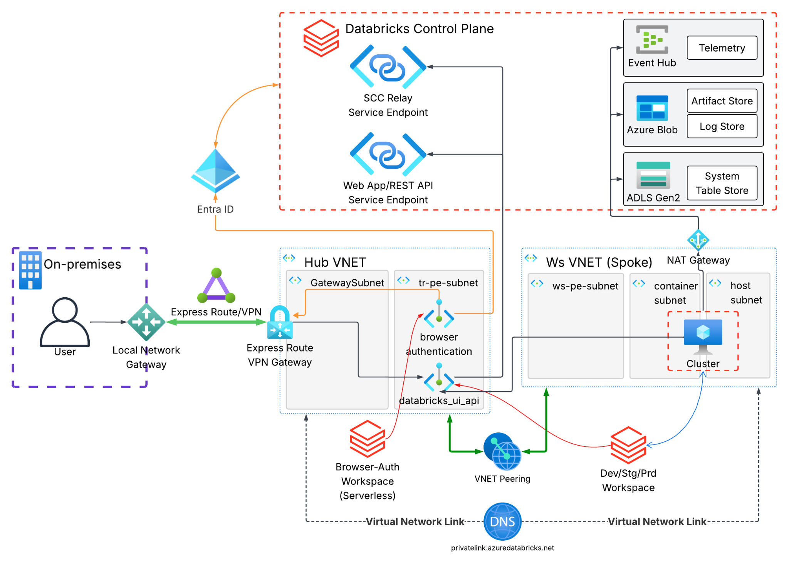
Usually, a shared Private DNS Zone is also used for this scenario. This is particularly helpful in scenarios where centralized DNS resolution is required. A single DNS zone can host all the A records, given that this DNS zone is liked to both VNETs (Hub for frontend access and Spoke for backend access).

Steps
Follow the same steps under Create a Metastore to enable Unity Catalog (Optional), Create required network resources and Create the Azure Databricks workspaces. Also, the same concepts described in Configure internal DNS to redirect user requests to the web application (front-end) and Disable Public Network Access for the workspace also apply to this architecture.

Peer Hub and Spoke VNETs
The peering connection can be configured from any of the Virtual Networks (Hub or Spoke). When you configure VNET peering, you must configure peering settings for both VNETs, which are named Remote virtual network peering settings and Local virtual network peering settings.
As additional requirements, you must ensure that the VNETs do not have overlapping IP addresses. It is not possible to create a peering connection with VNETs that have overlapping CIDR ranges.
In this example, we'll initiate the configuration from the Hub VNET, which will act as the Local virtual network, and therefore, the Workspace (Spoke) VNET will act as the Remote virtual network.
- From the Azure Portal, navigate to the Hub VNET. Expand the Settings section in the left side of the screen, and click Peerings. Click + Add.
- Provide details for Remote virtual network:
  - Provide a Peering link name, for example, spoke-to-hub.
  - For Peering type, select Virtual network.
  - Next, you must provide details about what is the Remote Virtual Network.You can either keep the I know my resource ID box disabled and select the Subscription and Virtual Network from the dropdowns, or check the I know my resource ID box and provide the VNET resource ID.
  - Under Remote virtual network peering settings, enable Allow '<remote-vnet-name>' to access '<local-vnet-name>' (first option) and Allow '<remote-vnet-name>' to receive forwarded traffic from '<local-vnet-name>' (second option). For Private Link setup, the other options are not required.
- Next, provide details for the Local virtual network:
  - Provide a Peering link name, for example, hub-to-spoke.
  - Under Local virtual network peering settings, enable Allow '<local-vnet-name>' to access '<remote-vnet-name>' (first option) and Allow '<local-vnet-name>' to receive forwarded traffic from '<remote-vnet-name>' (second option).
- Click Add.
Note: if you start the process from your Workspace (Spoke) VNET, it will instead act as the Local virtual network, while your Hub VNET will act as your Remote virtual network. The setup and options remain the same, but the link Peering link names will be inverted. Make sure to always follow the pattern: first remote-to-local, and then local-to-remote.
For VNET peering no additional configuration is required. Route tables are usually not required, since the platform automatically creates system routes for the peered VNET's address spaces in your route tables.

Create the Private Endpoints and DNS Zones
After creating both workspaces and peering the VNETs, we can proceed with creating the required private endpoints. For this setup, we'll only create two private endpoints, as described below:
Private Endpoint | Sub-resource | VNet / Subnet | Purpose
Backend (classic) + Frontend (inbound) PE | databricks_ui_api | Transit VNet (Hub) / hub-pe-subnet | End-user → workspace (Web App/REST API)  Clusters → Databricks control plane (RestAPI/SCC Relay)
Browser auth PE | browser_authentication | Transit VNet (Hub) / hub-pe-subnet | Azure Entra ID SSO callback
For the Hub and Spoke architecture, we will consider a single private DNS zone, linked to both Hub and Workspace (Spoke) VNETs.

Backend (classic) + Frontend (inbound) Private Endpoint
To create the Backend + Frontend Private Endpoint:.
- In the Azure portal, navigate to the Hybrid workspace we configured in Create the Azure Databricks hybrid workspace (dev/stg/prd):
  - In the Azure resource blade, expand the Settings section on the left side of the screen, and click Networking.
  - Click Private Endpoint Connections and then + Private Endpoint.
- In the Create a private endpoint page:
  - Select the correct Subscription and the Resource Group where the Hub VNET is created.
  - Provide a Name for the private endpoint. It is recommended to add a reference to the workspace and to note that this is a frontend private endpoint. For example: pe-<dev/stg/prod>-uiapi. The Network Interface Name should be filled automatically.
  - Select the Region. Make sure it matches the same region where you deployed your hybrid workspace.
  - Click Next: Resource.
- In the Resource tab, in the Target sub-resource dropdown, choose databricks_ui_api. Click Next: Virtual Network.
- In the Virtual Network tab, select the Hub VNET in the Virtual Network dropdown, and the hub-pe-subnet in the Subnet dropdown. Click Next: DNS.
- In the DNS tab, select Yes for the Integrate with private DNS zone option. For the configuration, select the correct Subscription, and for the Resource Group, choose the same Resource Group where your Hub VNET is located.
- Click Next: Tags and then Next: Review + create.
- Once the validation succeeds, click Create. The backend+frontend private endpoint should be ready in a few minutes.

Browser authentication Private Endpoint
For the browser authentication private endpoint:
- In the Azure portal, navigate to the Serverless workspace we configured in Create the Azure Databricks web authentication workspace:
  - In the Azure resource blade, expand the Settings section on the left side of the screen, and click Networking.
  - Click Private Endpoint Connections and then + Private Endpoint.
- In the Create a private endpoint page:
  - Select the correct Subscription and the Resource Group where the Hub VNET was created.
  - Provide a Name for the private endpoint. It is recommended to note this is a browser_authentication endpoint, as well as the region where this is created. For example: pe-browser-auth-<region>. The Network Interface Name should be filled automatically.
  - Select the Region. Make sure it matches the same region where you deployed your workspaces.
  - Click Next: Resource.
- In the Resource tab, in the Target sub-resource dropdown, choose browser_authentication. Click Next: Virtual Network.
- In the Virtual Network tab, select the Hub VNET in the Virtual Network dropdown, and the hub-pe-subnet in the Subnet dropdown. Click Next: DNS.
- In the DNS tab, select Yes for the Integrate with private DNS zone option. For the configuration, select the correct Subscription, and for the Resource Group, choose the same Resource Group where your Hub VNET is located.
- Click Next: Tags and then Next: Review + create.
- Once the validation succeeds, click Create. The browser authentication private endpoint should be ready in a few minutes.

Manage Private DNS zone links
After creating the private endpoints, the Private DNS Zone should already be configured as well, although it might not be linked to both Hub and Workspace (Spoke) VNETs. Make sure the DNS zone is liked to both VNETs:
- From the Azure Portal, navigate to the resource group where the Hub VNET is created, and search for the private DNS zone privatelink.azuredatabricks.net.
- In the left side of the screen, expand the DNS Management section and click Virtual Network Links.
- You should see a list of links for this DNS zone. It is very likely that you will only have a single record. Check the Virtual Network column: the Hub VNET should be listed. You must create the link for your Workspace (Spoke) VNET.
- Click + Add:
  - Provide a Link name, for example, spoke-vnet-link .
  - Provide Virtual network details.You can either keep the I know my resource ID box disabled and select the Subscription and Virtual Network from the dropdowns, or check the I know my resource ID box and provide the VNET resource ID.
  - You can keep Enable auto registration and Enable fallback to internet unchecked.
  - Click Create.
- Check if both VNETs are now listed in the Virtual Network column.

Testing the setup
You can test the setup by following the same steps listed in Testing the setup. The main difference is that both users and compute resources will resolve to the same private IP address when running the following command:
nslookup adb-<workspace_id>.azuredatabricks.net
Make sure to also test name resolution for web authentication:
nslookup <region>.pl-auth.azuredatabricks.net
If all dns queries returns private IP addresses and you can successfully spin up classic compute clusters from your workspace, the setup is complete.

